Date: 12/3/2020

GREETINGS EXCHANGE PROGRAM

On 29th International Day of Persons with Disabilities Ministry of Women, Children and Senior Citizens (MoWCSC) in coordination with National Federation of the Disabled Nepal (NFDN) organized Virtual Greetings Exchange Program as a main event on 3 December. The program was chaired and co-chaired by Honorable Minister for MoWCSC Lila Nath Shrestha and Secretary Yam Kumari Khatiwada respectively. NFDN President Mitral Lal Sharma, MoWCSC Joint-Secretary Tek Raj Niraula, President NGO Federation Jita Ram Lama were physically present at the MoWCSC to jointly host the program. Likewise, Government agencies, NFDN member organizations, OPDs, civil society organizations, national and international organizations attended the program via virtual means.
The program was inaugurated by Honorable Minister of the MoWCSC Lila Nath Shrestha by stating the national slogan for 29th IDPD. Joint Secretary of the Ministry Tek Raj Niraula welcomed the participants and shared the best wishes message from her Excellency President of Nepal Vidya Devi Bhandari and Rt. Honorable Prime Minister K.P. Sharma Oli.
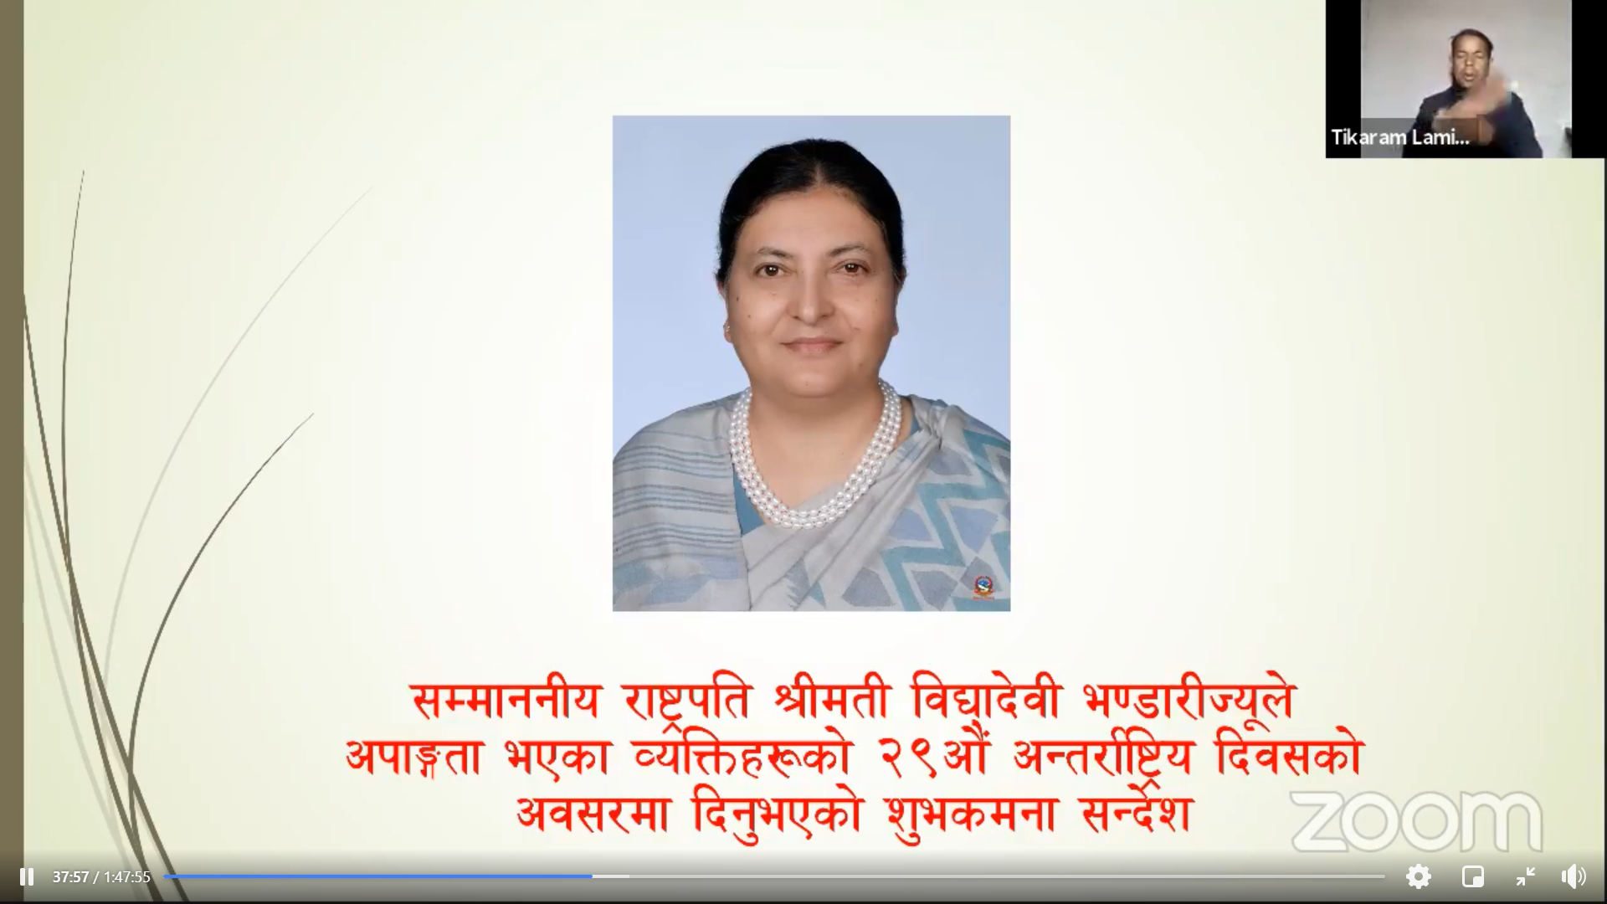
Figure 1: On 29th IDPD, MoWCSC shared Best Wishes Message from Her Excellency President of Nepal Vidya Devi Bhandari
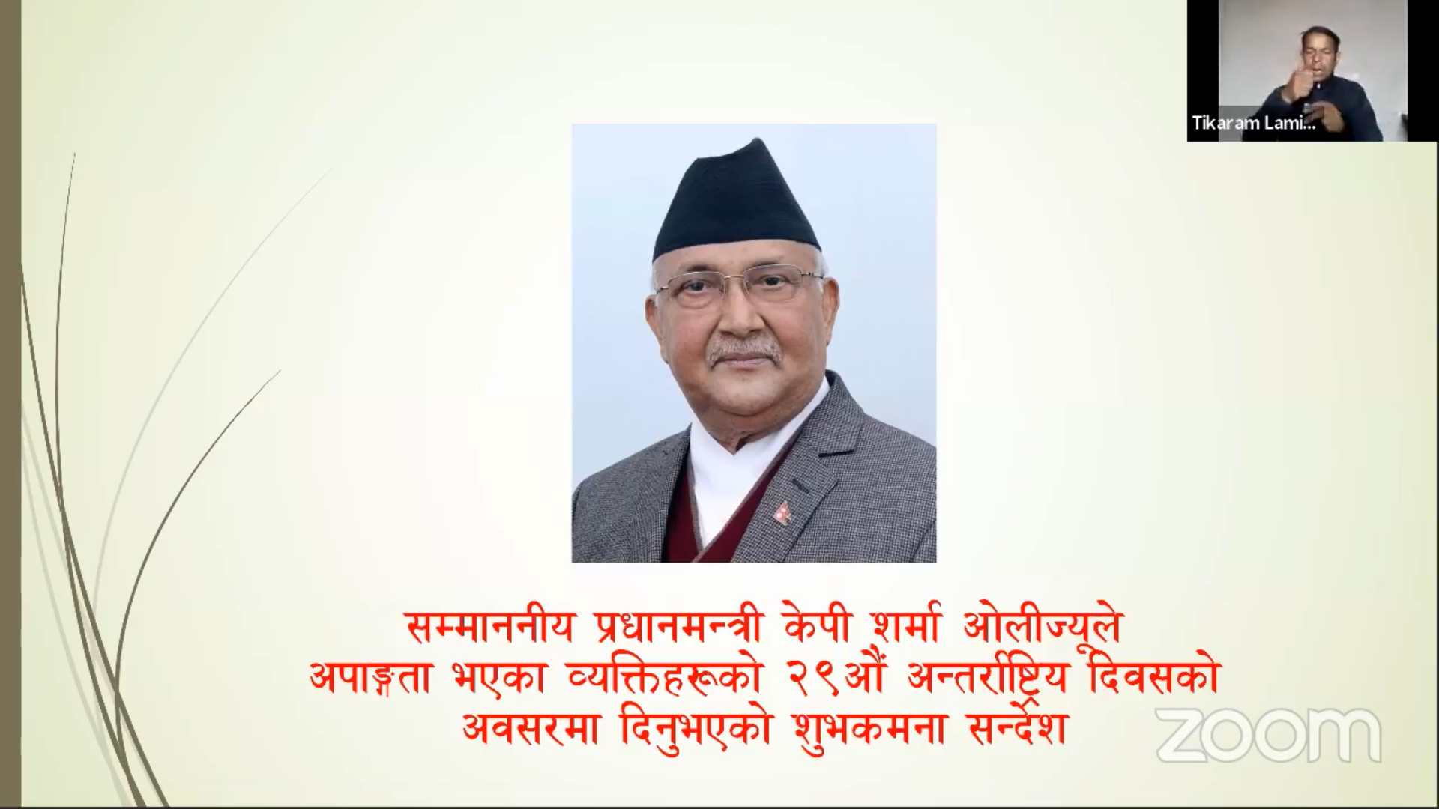
Figure 2: On 29th IDPD, MoWCSC shared the Best Wishes message from Rt. Honorable Prime Minister K.P. Sharma Oli
General Secretary Mr. Raju Basnet from NFDN was the master of ceremony of the program. Joint Secretary of MoWCSC shared information on current situation and future roadmap for persons with disabilities in the context of Nepal. In his presentation, he stressed on the milestones set from 1992 and onward, provision of constitutional and legal rights, available services as stated in the Disability Rights Regulation 2077, problems & challenges and the roadmap ahead.
Bir Nepali, Coordinator of International Non-Governmental Organization Disability Working Group in his remark highlighted on the importance of accessibility and inclusion particularly in present scenario of COVID-19.
President Mitra Lal Sharma, NFDN stated, “Despite the challenges and issues confronting us we are challenged to overcome them and move ahead. Most importantly, the introduction of Disability Rights Regulation 2077 per se is a milestone that we had been waiting since long. In its process of implementation, it can be amended and improved in collaboration with respective authorities. Further, Education Act is under amendment that ought to be disability inclusive, health parameters need to be fulfilled, formulation of Disability friendly statutes is essential. Responsibility lies on us to safeguard the achievements and move ahead which is possible only through collaboration. We can be hopeful of positive changes and move ahead”.
Honorable Minister for MoWCSC, Lila Nath Shrestha emphasized that, “It is imperative to make persons with disabilities self-reliant and independent. Formulation of 10 year workplan focusing on empowerment of persons with disabilities should be a priority; we need to bring programs which is more than just providing allowance”.
Secretary of MoWCSC Yam Kumari Khatiwada during her final remarks applauded the achievements so far and stated “disability is a cross cutting issue and an action plan with strategy need to be formulated for which MoWCSC will coordinate.”
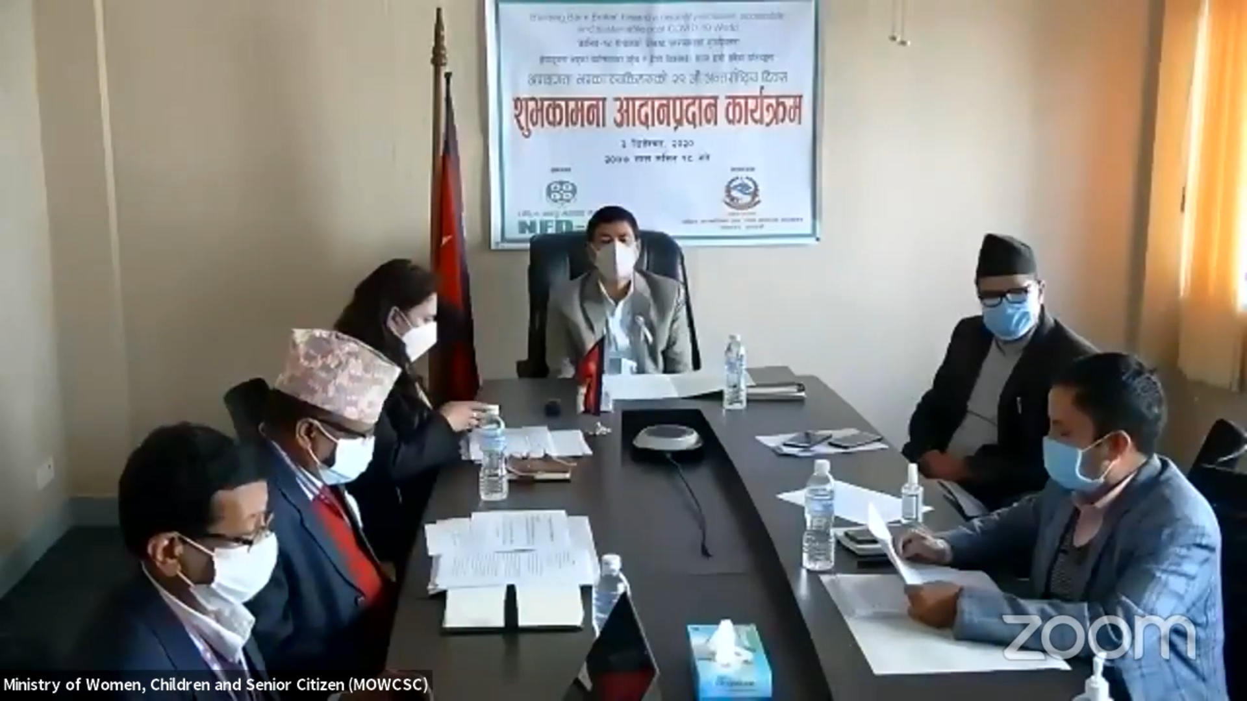
Figure 3: Greeting Exchange Program at the MOWCSC on 29th IDPD
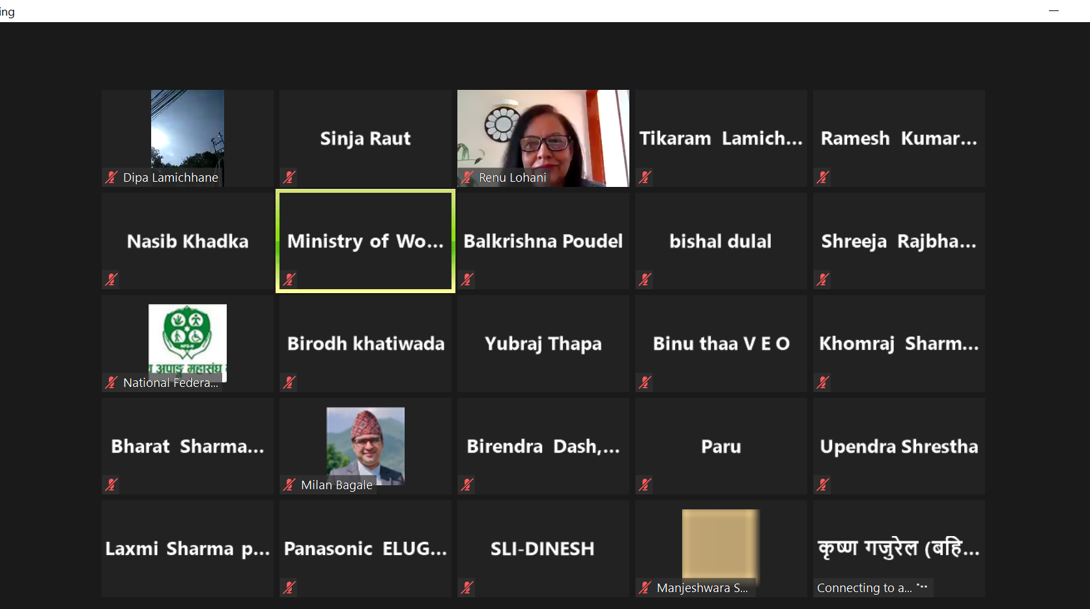
Figure 4: Screenshot of guests present in the Greeting Exchange Program

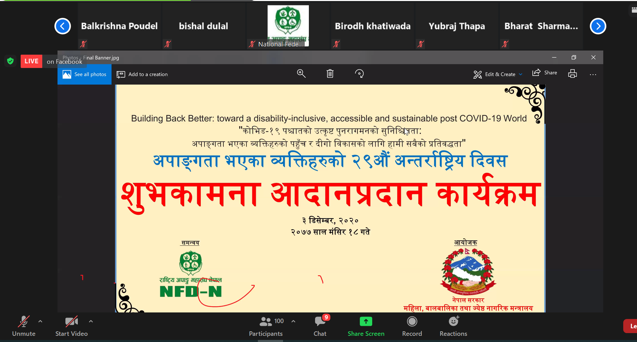
Figure 5: Banner of jointly organized Greeting Exchange Program by MoWCSC and NFDN
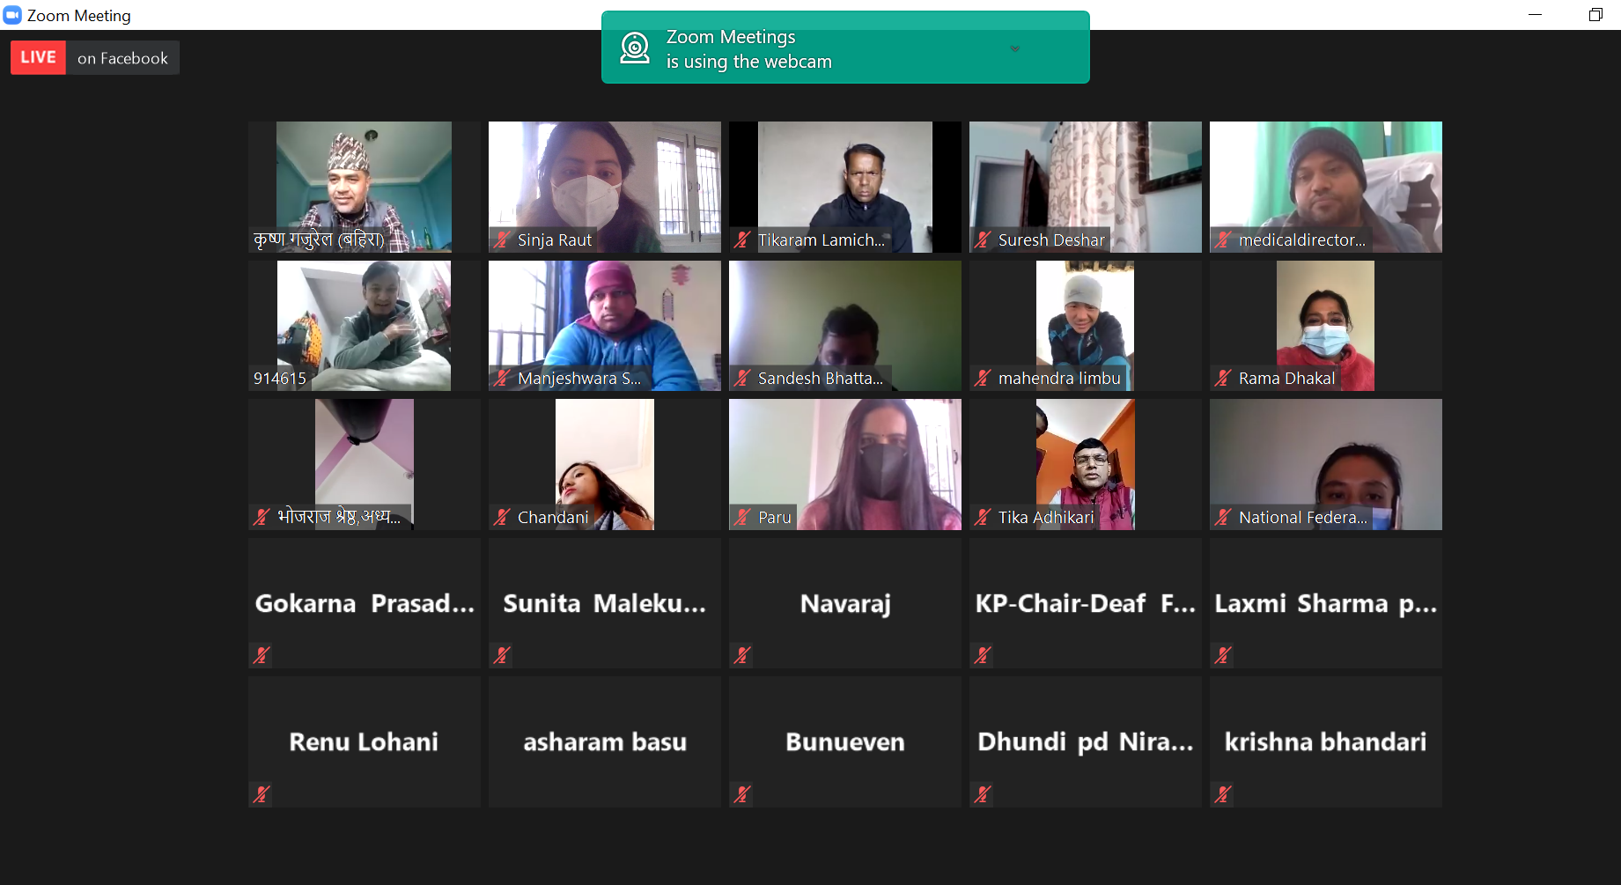
Figure 6: Screenshot of guests who joined the Greetings Exchange Program

