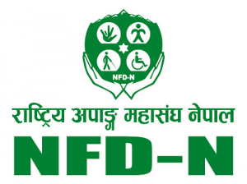 Date: 12/2/2020

PRESS MEET TO OBSERVE 29th INTERNATIONAL DAY OF PERSONS WITH DISABILITIES
The International Day of Persons with Disabilities (IDPD) is annually observed on 3 December to promote the full and equal participation of persons with disabilities and to take action for the inclusion of persons with disabilities in all aspects of society and development.
To commemorate the 29th International Day of Persons with Disabilities, a virtual press meet was organized on 2 December by Ministry of Women, Children and Senior Citizen in coordination with NFDN. National media, Organization of Persons with Disabilities, NFDN Federal and provincial bearers attended the virtual press meet. During the press meet, General Secretary Raju Basnet, highlighted the achievements made over the years in the disability sector and detailed the disability issues to be addressed collectively.
Media persons raised concern regarding NFDN’s disability inclusive efforts, plans to uplift under-represented impaired groups, and on the usage of Washington Group Questionnaire in the upcoming census 2078 (2021).
General Secretary emphasized that, “power of voice” cannot be underestimated and enhancing voice of persons with disabilities on issues concerning them is empowering and more sustainable. Regarding disability inclusive data, he explained NFDN’s relentless effort to influence disability-disaggregated data and production of thematic report in the upcoming census.
NFDN President Mitra Lal Sharma, during his final remarks reiterated Media roles in raising awareness on disability issues. He emphasized that, disability is unpredictable and can happen at any age, persons with disabilities should be taken as a part of family, society. Mainstreaming disability in development agenda should be a priority.
Furthermore, NFDN will mark the celebration with a nine-day programme from 2 December to 10 December under the international theme: "Building back better: towards an inclusive, accessible and sustainable post COVID-19 world” by, for and with the persons with disabilities". NFDN will organize a series of events utilizing digital platform to raise awareness on cross cutting issues.
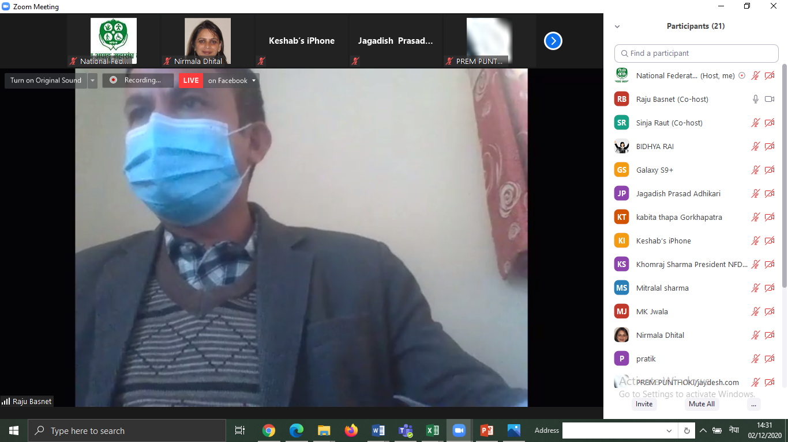
Figure 1: Screenshot of virtual press meet held on 2 December 2020 to commemorate 29th International Day of Persons with Disabilities

