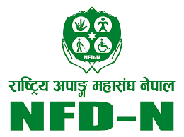
National Federation of Disabled Nepal’s Appeal
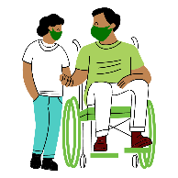  Vaccination  Center  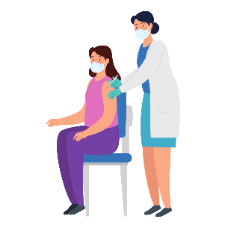 | - Prioritize persons with disabilities in the vaccination center and/or provide mobile clinic options  - Arrange for an accessible venue including parking facilities during the vaccination process
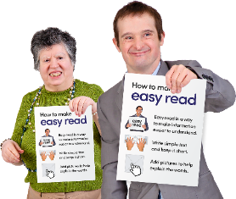 | - Produce and disseminate Information from the Health ministry and agencies in accessible and alternative formats  - Ensure data are disaggregated and collected in terms of disability as well

